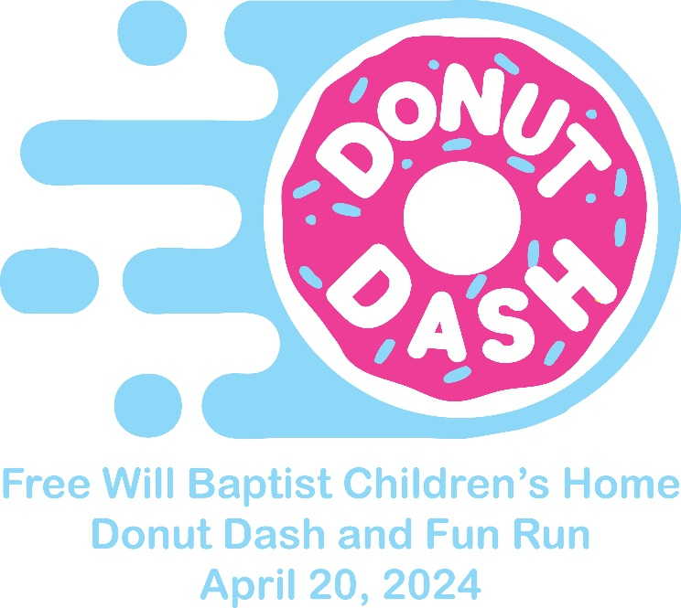

The Free Will Baptist Children’s Home has been a loving home for hurting Children since 1947. We are located in Eldridge, AL, we are an incorporated, 501 (c) 3 non-profit organization, licensed by the Alabama Department of Human Services. We are a private Children’s Home who operates on the donations and generosity of others. You can visit fwbhome.org for more information.
Would your business or group like to be apart making the Free Will Baptist Children’s Home 4th annual 5k a success?
T-Shirt Sponsor-$350. Business or group name will be on the back of the Race Shirt and will be listed on the Children’s Home Website. Must be received by March 15rd for t shirt printing.
Name of business and location as you want it listed and contact info:

Sign Sponsor-$100. Business or group name will have a sign posted along route and will be listed on the Children’s Home Website.
Name of Business or group as you want it listed and contact info:

Pertinent Information:
The FWBCH is an IRS 501c3 Exempt Organization
EIN # 63 0344 305
AL Tax Exempt Act # 1591

